**CHANDIGARH COLLEGE OF ENGINEERING AND TECHNOLOGY (DEGREE WING)**

Government Institute under Chandigarh (UT) Administration, Affiliated to Panjab University, Chandigarh

Sector-26, Chandigarh. PIN -160019

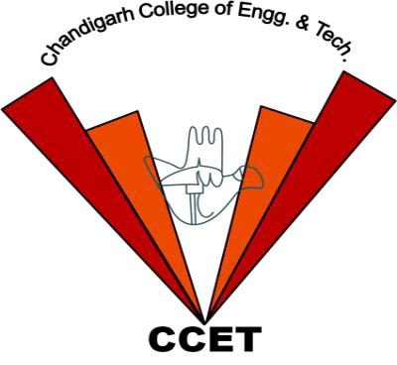

**Bachelor of Engineering**

**IN COMPUTER SCIENCE AND ENGINEERING**

**3rd Sem**

**2024**

**Database System(Practical)**

**PRACTICAL-5**

**Subject Code: CS 352**

**Submitted by** **Submitted To**

**Sanatan Sharma**

**Dr. Dheerendra Singh**

**(Roll no:CO23355)** **(Professor)**

**Date of assignment:**

**8th August, 2024**

**Date of submission:**

**22nd August, 2024**